

PROJECT FILE

CLASS-XII

**SHOPPING MALL BILLING SYSTEM**

ACADEMIC SESSION 2022 - 23

**Computer Science Python (083)**

|  |  |
| --- | --- |
| **Students’ Name:** | VINEET YADAV, RAJAN JAISWAL, NAITIK YADAV & MANGESH KUMAR SONI |
| **Board Roll No.:** | TO BE ENTERED |
| **Class & Sec.:** | 12-A1, 12-A2 |

|  |  |
| --- | --- |
| **Subject Teacher’s Name:** | Pankaj Shukla |



**INDEX**

|  |  |  |
| --- | --- | --- |
| 1 | Acknowledgement |  |
| 2 | **Certificate of Authenticity** |  |
| 3 | **Introduction** |  |
| 4 | **Header Files** |  |
| 5 | **Requirements** |  |
| 6 | **Screen Shots** |  |
| 7 | **Code** |  |
| 8 | **Bibliography** |  |



**Acknowledgment**

This project was made by VINEET, RAJAN, NAITIK & MANGESH of Class 12th and we would like to express our sincere gratitude to our Computer Science teacher **Mr. Pankaj Shukla** for his vital support, guidance, and encouragement without which this project would have not come forth.

We would also like to express our gratitude to the school and to the Principal, **Ms. Swati S Shaligram** for being a constant support in the completion of this project.We would also like to thank our friends and classmates for encouraging us during the course of this project. Finally, we would like to thank CBSE for giving us this opportunity to undertake this project.



Certificate of Authenticity

This is to **certify** that

**VINEET YADAV, RAJAN JAISWAL, NAITIK YADAV & MANGESH KUMAR SONI**

Of Class 12 have prepared the report on the project entitled

**“SHOPPING MALL BILLING SYSTEM”**

The report is the result of their collaborative efforts & endeavours. The report is found worthy of acceptance as the final project report for the subject

**Computer Science Python (083)**

Of Class XII. They have prepared the report under my guidance and supervision in the academic year 2023-24, as per CBSE guidelines.

|  |  |
| --- | --- |
| Pankaj Shukla  HoD  Computer Science Department  VidyaGyan – Sitapur  Uttar Pradesh | **Ms. Swati S Shaligram**  **Principal**  VidyaGyan  Sitapur  Uttar Pradesh |

**Introduction**

**This project is about a shopping mall billing system in which a customer can order one or many products in accordance with his need and at last an invoice will be generated which will display his bill.**

**An administrator can create a new product if his stock of old products is over, can display all products or a specific product, can modify a product, delete a product, and can also display a product price list.**

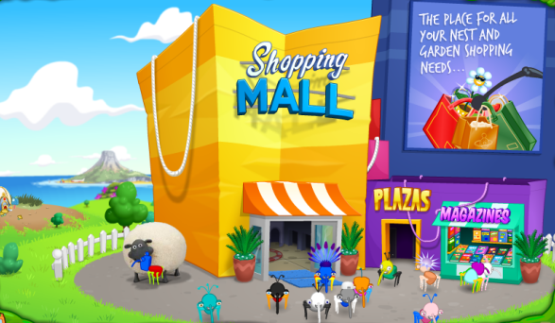

* **Included Library Files:**
* **mysql.connector: To establish Python & Mysql database connection.**
* **Datetime: To work with Current date & time in Python.**
* **random: To use random.randint () to generate invoice number while billing**
* **System Requirements:**
* **Python 3.10.6 (64-bit)**
* **Modern Operating System:**
* **Windows 7 or 10**
* **x86 64-bit CPU (Intel / AMD architecture)**
* **4 GB RAM**
* **5 GB free disk space**

**DATABASE TABLES:**

1. **PRODUCT TABLE:**

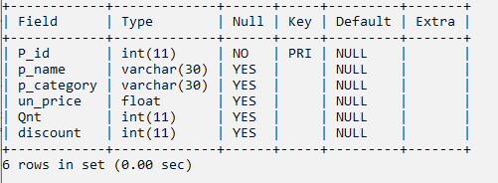

**PROGRAM:**

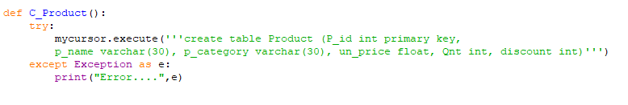

**DATABASE TABLES:**

1. **PRODUCT_CUSTOMER TABLE:**

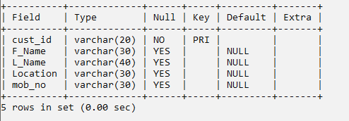

**PROGRAM:**

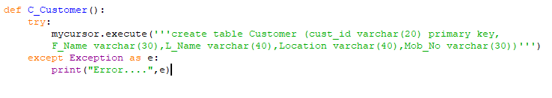

1. **CUSTOMER TABLE:**

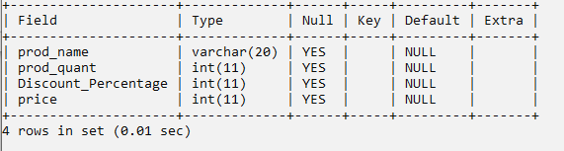

**PROGRAM:**

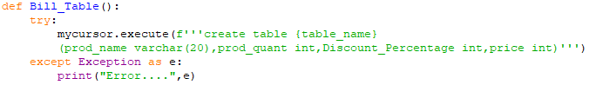

**SCREENSHOTS**

1. **MAIN MENU SCREEN**

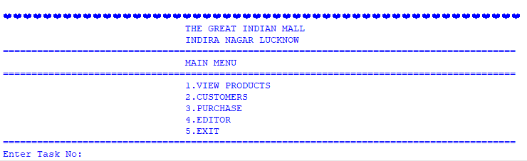

1. **VIEW PRODUCT**

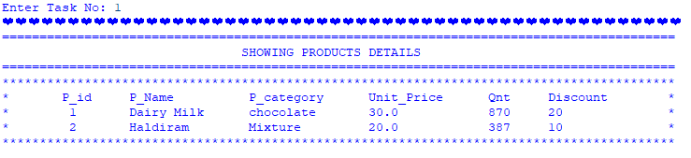

1. **PURCHASE MENU**

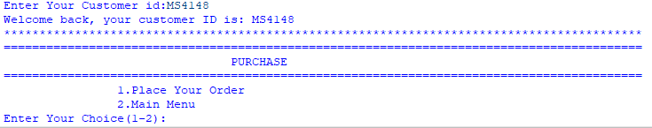

1. **EDITOR MENU**

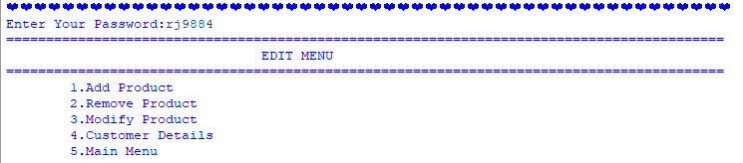

1. **REGISTRATION SCREEN**

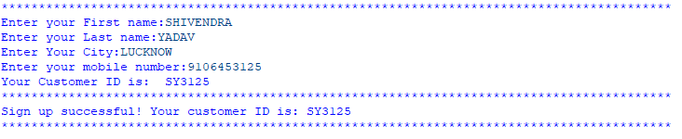

1. **PLACE ORDER SCREEN**

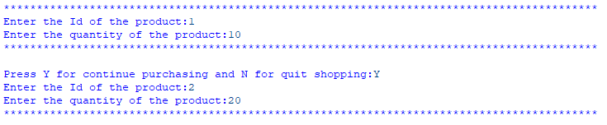

1. **PRINTED BILL**

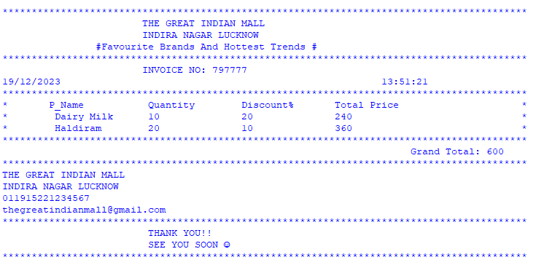

1. **ADD PRODUCT SCREEN**

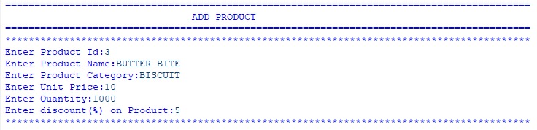

1. **REMOVE PRODUCT SCREEN**

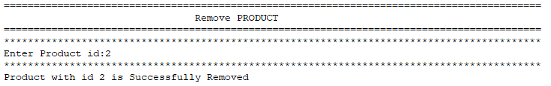

* **MODIFIED TABLE**

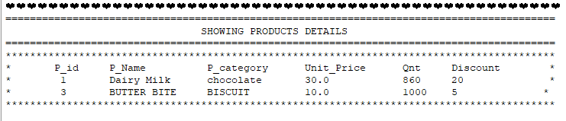

1. **MODIFY PRODUCT SCREEN**

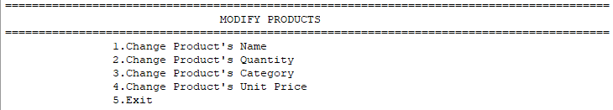

1. **CHANGE PRODUCT NAME SCREEN**

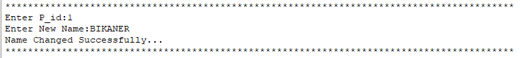

* **MODIFIED TABLE**

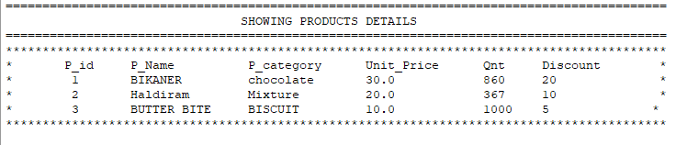

1. **CHANGE PRODUCT QNT SCREEN**

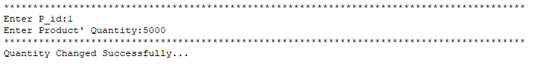

* **MODIFIED TABLE**

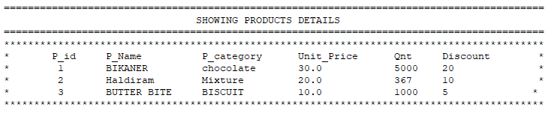

1. **CHANGE PRODUCT CATEGORY**

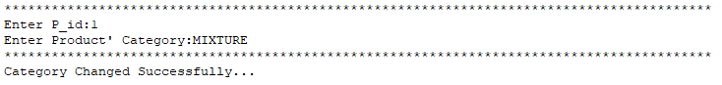

* **MODIFED TABLE**

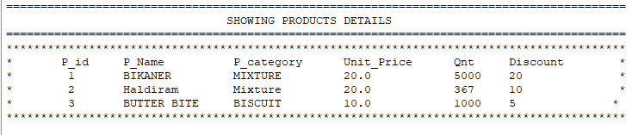

1. **CHANGE PRODUCT’S UNIT PRICE**

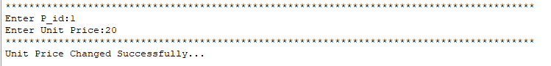

* **MODIFIED TABLE**



1. **CUSTOMER DETAILS SCREEN**

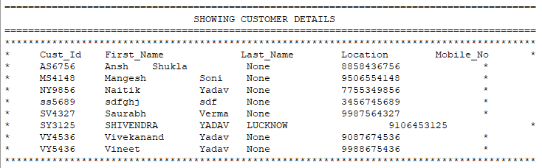

**Python Source Code:**

**import random**

**import mysql.connector**

**try:**

**connection=mysql.connector.connect(**

**host="localhost",**

**user="root",**

**password="",**

**database="Shopping"**

**)**

**if connection.is_connected():**

**mycursor=connection.cursor()**

**else:**

**print("Connection Error...Kindly check")**

**except:**

**print("Database Error....")**

**def C_Product():**

**try:**

**mycursor.execute('''create table Product (P_id int primary key,**

**p_name varchar(30), p_category varchar(30), un_price float, Qnt int, discount int)''')**

**except Exception as e:**

**print("Error....",e)**

**def C_Customer():**

**try:**

**mycursor.execute('''create table Customer (cust_id varchar(20) primary key,**

**F_Name varchar(30),L_Name varchar(40),Location varchar(40),Mob_No varchar(30))''')**

**except Exception as e:**

**print("Error....",e)**

**def load_tables():**

**try:**

**mycursor.execute("show tables")**

**data=mycursor.fetchall()**

**for i in data:**

**if i[0]!="Customer":**

**C_Customer()**

**for i in data:**

**if i[0]!="Product":**

**C_Product()**

**except Exception as e:**

**print("Error....",e)**

**def view_products():**

**try:**

**print('='*90)**

**print("\t\t\t\tSHOWING PRODUCTS DETAILS")**

**print('='*90)**

**print("*"*90)**

**mycursor.execute("select * from Product")**

**data=mycursor.fetchall()**

**print("*","\tP_id\t","P_Name\t\t","P_category\t","Unit_Price\t","Qnt\t","Discount"," "*6,"*")**

**for i in data:**

**print("*\t",i[0],"\t",i[1],"\t",i[2],"\t",i[3],"\t\t",i[4],"\t",i[5]," "*12,"*")**

**print("*"*90)**

**except Exception as e:**

**print("Error....",e)**

**def view_customer():**

**try:**

**print('='*90)**

**print("\t\t\t\tSHOWING CUSTOMER DETAILS")**

**print('='*90)**

**mycursor.execute("select * from customer")**

**data=mycursor.fetchall()**

**print("*"*90)**

**print("*"," Cust_Id\t","First_Name\t","\tLast_Name\t","Location\t","Mobile_No"," "*5,"*")**

**for i in data:**

**print("* ",i[0],"\t",i[1],"\t",i[2],"\t",i[3],"\t\t",i[4]," "*12,"*")**

**print("*"*90)**

**except Exception as e:**

**print("Error....",e)**

**def Add_P():**

**try:**

**print('='*90)**

**print("\t\t\t\tADD PRODUCT")**

**print('='*90)**

**print("*"*90)**

**while True:**

**p_id=int(input("Enter Product Id:"))**

**p_name=input("Enter Product Name:")**

**p_category=input("Enter Product Category:")**

**un_price=float(input("Enter Unit Price:"))**

**Qnt=int(input("Enter Quantity:"))**

**dis=int(input("Enter discount(%) on Product:"))**

**mycursor.execute('''insert into product values (**

**{},"{}","{}",{},{},{})'''.format(p_id,p_name,p_category,un_price,Qnt,dis))**

**connection.commit()**

**print("*"*90)**

**print("Product with id {} is Successfully Added".format(p_id))**

**ch=input("Want to Add More Products(Y/N):")**

**if ch in 'nN':**

**break**

**except Exception as e:**

**print("Error....",e)**

**def Remove_P():**

**try:**

**print('='*90)**

**print("\t\t\t\tRemove PRODUCT")**

**print('='*90)**

**print("*"*90)**

**while True:**

**p_id=int(input("Enter Product id:"))**

**mycursor.execute("Delete from Product where P_id= {}".format(p_id))**

**print("*"*90)**

**print("Product with id {} is Successfully Removed".format(p_id))**

**ch=input("Want to Remove More Products(Y?N):")**

**if ch in 'nN':**

**break**

**except Exception as e:**

**print("Error....",e)**

**def Modify_P():**

**try:**

**print('='*90)**

**print("\t\t\t\tMODIFY PRODUCTS")**

**print('='*90)**

**while True:**

**print("\t\t1.Change Product's Name")**

**print("\t\t2.Change Product's Quantity")**

**print("\t\t3.Change Product's Category")**

**print("\t\t4.Change Product's Unit Price")**

**print("\t\t5.Exit")**

**ch=input("Enter Your choice(1-6):")**

**if ch not in '123456':**

**print("\tPlz Enter Numbers Only...")**

**elif ch=='1':**

**try:**

**print("*"*90)**

**p_id=input("Enter P_id:")**

**N_Name=input("Enter New Name:")**

**mycursor.execute("update Product set p_name= '{}' where P_id= '{}'".format(N_Name,p_id))**

**connection.commit()**

**print("Name Changed Successfully...")**

**print("*"*90)**

**print("\n")**

**except Exception as e:**

**print("Error....",e)**

**elif ch=='2':**

**try:**

**print("*"*90)**

**p_id=input("Enter P_id:")**

**Quantity=input("Enter Product' Quantity:")**

**mycursor.execute("update Product set Qnt= {} where P_id= '{}'".format(Quantity,p_id))**

**connection.commit()**

**print("*"*90)**

**print("Quantity Changed Successfully...")**

**print("\n")**

**except Exception as e:**

**print("Error....",e)**

**elif ch=='3':**

**try:**

**print("*"*90)**

**p_id=input("Enter P_id:")**

**category=input("Enter Product' Category:")**

**mycursor.execute("update Product set p_category= '{}' where P_id= '{}'".format(category,p_id))**

**connection.commit()**

**print("*"*90)**

**print("Category Changed Successfully...")**

**print("\n")**

**except Exception as e:**

**print("Error....",e)**

**elif ch=='4':**

**try:**

**print("*"*90)**

**p_id=input("Enter P_id:")**

**unprice=input("Enter Unit Price:")**

**mycursor.execute("update Product set un_price= '{}' where P_id= '{}'".format(unprice,p_id))**

**connection.commit()**

**print("*"*90)**

**print("Unit Price Changed Successfully...")**

**print("\n")**

**except Exception as e:**

**print("Error....",e)**

**elif ch=='5':**

**break**

**except Exception as e:**

**print("Error....",e)**

**def Editor():**

**try:**

**while True:**

**pas=input("Enter Your Password:")**

**if pas.lower()!='rj9884':**

**print("Wrong Password")**

**else: break**

**while True:**

**print('='*90)**

**print("\t\t\t\tEDIT MENU")**

**print('='*90)**

**print("\t1.Add Product")**

**print("\t2.Remove Product")**

**print("\t3.Modify Product")**

**print("\t4.Customer Details")**

**print("\t5.Main Menu")**

**ch=input("Enter Your choice(1-5):")**

**if ch not in '12345':**

**print("Plz Enter Numbers Only...")**

**elif ch=='1':**

**Add_P()**

**elif ch=='2':**

**Remove_P()**

**elif ch=='3':**

**Modify_P()**

**elif ch=='4':**

**view_customer()**

**else: break**

**except Exception as e:**

**print("Error....",e)**

**def cust_id_generetor():**

**try:**

**print("*"*90)**

**F_name = input("Enter your First name:")**

**L_name = input("Enter your Last name:")**

**Location= input("Enter Your City:")**

**while True:**

**mobile =input("Enter your mobile number:")**

**if len(mobile)!=10:**

**print("Invalid Mobile Number..Enter 10 digits only")**

**else: break**

**cust_id=F_name[:1] + L_name[:1] + str(mobile[6:11])**

**print("Your Customer ID is: ",cust_id)**

**print("*"*90)**

**return cust_id,F_name,L_name,Location,mobile**

**except Exception as e:**

**print("Error....",e)**

**def cust_id_exist():**

**try:**

**print("*"*90)**

**mycursor.execute("select cust_id from customer")**

**result=mycursor.fetchall()**

**global cust_id**

**cust_id=input("Enter Your Customer id:")**

**Lower=cust_id.lower()**

**final=0**

**for i in result:**

**if i[0].lower()==Lower:**

**print("Welcome back, your customer ID is:", cust_id)**

**print("*"*90)**

**final=1**

**if final==0:**

**print("Customer id does not exist...kindly register...")**

**registor()**

**except Exception as e:**

**print("Error....",e)**

**def registor():**

**try:**

**print("Start Your Registration...")**

**cust_id,F_name,L_name,Location,mobile=cust_id_generetor()**

**mycursor.execute('''insert into customer (cust_id,F_name,L_name,Location,mob_no)**

**values ("{}","{}","{}","{}","{}")'''.format(cust_id,F_name,L_name,Location,mobile))**

**connection.commit()**

**print("Sign up successful! Your customer ID is:", cust_id)**

**print("*"*90)**

**except Exception as e:**

**print("Error....",e)**

**def customers():**

**try:**

**print('='*90)**

**print("\t\t\t\tCUSTOMER DETAILS")**

**print('='*90)**

**ask=input("Do you have the Customer_id(Y/N):")**

**if ask in "Yy":**

**cust_id_exist()**

**shopping=input("Do you want to shop now(Y/N):")**

**if shopping in "yY":**

**purchase()**

**if ask in "Nn":**

**registor()**

**except Exception as e:**

**print("Error....",e)**

**def purchase():**

**try:**

**view_products()**

**cust_id_exist()**

**while True:**

**print('='*90)**

**print("\t\t\t\tPURCHASE")**

**print('='*90)**

**print("\t\t1.Place Your Order")**

**print("\t\t2.Main Menu")**

**ch=input("Enter Your Choice(1-2):")**

**if ch not in '12':**

**print("Plz Enter Numbers Only...")**

**elif ch=='1':**

**buyprod()**

**elif ch=='2':**

**break**

**except Exception as e:**

**print("Error....",e)**

**from datetime import\***

**def buyprod():**

**try:**

**print("*"*90)**

**a=random.randint(100000,999999)**

**global table_name,prod_quant,price**

**table_name=cust_id+'PLASSIO'**

**def Bill_Table():**

**try:**

**mycursor.execute(f'''create table {table_name}**

**(prod_name varchar(20),prod_quant int,Discount_Percentage int,price int)''')**

**except Exception as e:**

**print("Error....",e)**

**Bill_Table()**

**while True:**

**Id=input("Enter the Id of the product:")**

**mycursor.execute(f"select p_name from product where p_id ='{Id}'")**

**result4=mycursor.fetchone()**

**prod_name=result4[0]**

**#To check availability of the product**

**prod_quant=int(input("Enter the quantity of the product:"))**

**mycursor.execute(f"select Qnt from product where p_name = '{prod_name}'")**

**result=mycursor.fetchone()**

**if result[0]>=prod_quant:**

**#fetching the price of the product**

**mycursor.execute(f"select un_price from product where p_name='{prod_name}'")**

**result=mycursor.fetchone()**

**price=result[0]**

**#Applying the discount on the product**

**mycursor.execute(f"select discount from product where p_name = '{prod_name}'")**

**result2=mycursor.fetchone()**

**discount=result2[0]**

**netper=100-discount**

**#Creating the Bill Table**

**total_price=((prod_quant*price)*netper)/100**

**#Inserting the Data in Bill Table**

**mycursor.execute(f"insert into {table_name} values('{prod_name}',{prod_quant},{discount},{total_price})")**

**connection.commit()**

**#Updating the new quantity of the Product**

**mycursor.execute(f"select Qnt from product where P_id = '{Id}'")**

**result=mycursor.fetchone()**

**newQuant=int(result[0])-prod_quant**

**mycursor.execute(f"UPDATE product SET Qnt = {newQuant} WHERE P_id = '{Id}'")**

**connection.commit()**

**print("*"*90)**

**choice=input('\nPress Y for continue purchasing and N for quit shopping:')**

**#Generating the bill**

**if choice in 'Nn':**

**print('\t\t\t\tYour bill is generated\n\n')**

**mycursor.execute(f"select sum(price) from {table_name}")**

**result1=mycursor.fetchone()**

**print("*"*90)**

**print("\t\t\tTHE GREAT INDIAN MALL \n \t\t\tINDIRA NAGAR LUCKNOW ")**

**print("\t\t#Favourite Brands And Hottest Trends #")**

**print("*"*90)**

**print("\t\t\tINVOICE NO:",a)**

**today = date.today()**

**d1 = today.strftime("%d/%m/%Y")**

**now = datetime.now()**

**a = now.strftime("%H:%M:%S")**

**print( d1,"\t\t\t\t\t\t\t",a)**

**print("*"*90)**

**mycursor.execute("SELECT CUST_ID,F_NAME,L_NAME,LOCATION,MOB_NO FROM CUSTOMER where CUST_ID='{cust_id}'")**

**data = mycursor.fetchall()**

**for i in data:**

**print(" ","CUSTOMER_ID:",i[0],"\t")**

**print(" ","CUSTOMER_NAME:",i[1],i[2],"\t")**

**print(" ","ADDRESS:",i[2],"\t")**

**print(" ","PHONE_NO:",i[3],"\t")**

**mycursor.execute(f'select* from {table_name}')**

**myresult=mycursor.fetchall()**

**print("*","\tP_Name\t\t","Quantity\t","Discount%\t","Total Price"," "*19,"*")**

**for i in myresult:**

**print("*","\t",i[0],"\t",i[1],"\t\t",i[2],"\t\t",i[3]," "*27,"*")**

**print("*"*90)**

**print(" "*69,"Grand Total:",result1[0])**

**print("*"*90)**

**print("THE GREAT INDIAN MALL")**

**print("INDIRA NAGAR LUCKNOW")**

**print("011915221234567")**

**print("thegreatindianmall@gmail.com")**

**print("*"*90)**

**print("\t\t\t THANK YOU!!")**

**print("\t\t\t SEE YOU SOON ☺")**

**print("*"*90)**

**break**

**else:**

**print("Product out of stock")**

**print("*"*90)**

**X=input('Press Y To Continue purchasing:')**

**z='yY'**

**if X not in z:**

**break**

**mycursor.execute(f'drop table {table_name}')**

**except Exception as e:**

**print("Error....",e)**

**mycursor.execute(f'drop table {table_name}')**

**#load_tables()**

**while True:**

**print("\n")**

**print("❤"*52)**

**print("\t\t\t\tTHE GREAT INDIAN MALL")**

**print("\t\t\t\tINDIRA NAGAR LUCKNOW")**

**print('='*90)**

**print("\t\t\t\tMAIN MENU")**

**print('='*90)**

**print("\t\t\t\t1.VIEW PRODUCTS")**

**print("\t\t\t\t2.CUSTOMERS")**

**print("\t\t\t\t3.PURCHASE")**

**print("\t\t\t\t4.EDITOR")**

**print("\t\t\t\t5.EXIT")**

**print('='*90)**

**ch=input("Enter Task No: ")**

**print("❤"*52)**

**if ch not in '12345':**

**print("\tPlz Enter Numbers Only...")**

**elif ch=='1':**

**view_products()**

**elif ch=='2':**

**customers()**

**elif ch=='3':**

**purchase()**

**elif ch=='4':**

**Editor()**

**elif ch=='5':**

**break**

**BIBLIOGRAPHY**

**We have taken use of the following sources in making our project a successful one:**

* [**www.w3schools.com**](http://www.w3schools.com)
* [**www.geeksforgeeks.org**](http://www.geeksforgeeks.org)
* [**www.programiz.com**](http://www.programiz.com)
* [**www.tutorialspoint.com**](http://www.tutorialspoint.com)
* **Class 12 Computer Science Textbook**



